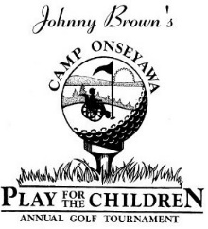

CAMP ONSEYAWA GOLF TOURNAMENT
Saturday, June 10, 2023 at Silver Creek Golf Course in Waterloo
Sponsorship Form
Presenting Sponsor: $1500
Includes lunch, golf, cart and dinner for a foursome, Green Sponsor and Major Signage and Recognition

Hole in One Sponsor: $1000
Includes lunch, golf, cart and dinner for a foursome, Green Sponsor and Special Mention

Eagle Sponsor: $600 Includes lunch, golf, cart and dinner for a foursome, and a Green Sponsor
Birdie Sponsor: $500 Includes lunch, golf, cart and dinner for a foursome, and a Hole Sponsor
Green Sponsor: $250 Includes signage at a green
Hole Sponsor: $150 Includes signage at a hole

Name (to be used on sign): _________________________________________________
Address: ________________________________________________________________
Contact email/phone: _____________________________________________________

Please make your check payable to Rotary Camp Onseyawa Golf Tournament.
MAIL CHECK AND FORM BY JUNE 2, 2023 to: Liz Becht
142 Ovid Street
Seneca Falls, NY 13148

Rotary Camp ONSEYAWA is a 501(c)(3) organization. Thank you for your contribution!

