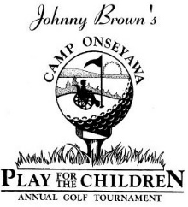
Saturday, June 13, 2020 at Silver Creek Golf Course in Waterloo
Sponsorship Form
Presenting Sponsor: $2500
Includes lunch, golf and dinner for a foursome, Green Sponsor and Hosting Status

Hole in One Sponsor: $1,000
Includes lunch, golf and dinner for a foursome, Green Sponsor and Special Mention

Eagle Sponsor: $600 Includes lunch, golf and dinner for a foursome, and a Green Sponsor
Birdie Sponsor: $500 Includes lunch, golf and dinner for a foursome, and a Hole Sponsor
Green Sponsor: $250 Includes signage at a green
Hole Sponsor: $150 Includes signage at a hole

Name (to be used on sign): _________________________________________________

Address: ________________________________________________________________

Contact email/phone: _____________________________________________________

Please make your check payable to Rotary Camp Onseyawa.
Mail form and check by May 29, 2020 to: Liz Becht
142 Ovid St.
Seneca Falls, NY 13148

For your convenience, the sponsorship form is also available online:
http://www.safepayevents.com/?Event=ONSEYAWAGolfTournament2020
Rotary Camp ONSEYAWA is a 501(c)(3) organization. Thank you for your contribution!

