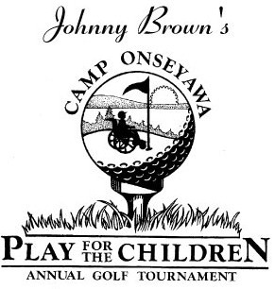
Sponsorship Form
Check one:
Hole Sponsor: $150 [ ] Green Sponsor: $250 [ ] Par Sponsor: $400 [ ]
Birdie Sponsor: $500 [ ] Eagle Sponsor: $600 [ ] Hole in One Sponsor: $1,000 [ ]
Double Eagle-Presenting Sponsor: $5,000 [ ]

Name/Company Name: ____________________________________________________

Location: ________________________________________________________________

Contact email/phone: _____________________________________________________

Message: _______________________________________________________________

Please make checks payable to Rotary Camp Onseyawa.
Mail this form with your check to: Liz Becht 142 Ovid St. Seneca Falls, NY 13148 by May 24, 2019.
For your convenience, online sponsorship is also available at:
http://www.safepayevents.com/?Event=ONSEYAWAGolfTournament2019

Rotary Camp ONSEYAWA is a 501(c)(3) organization. Thank you for your contribution!

